Basic IT Troubleshooting Tips

QUIT is your best friend
- In any application, you can ‘Quit’ and then re-open it to see if this resolves your issues. To quit, use either one of these methods.

Option 1.
Click on the name of your App in the top Left Menu bar (in this example I am using Microsoft Word). Then click on Quit Word.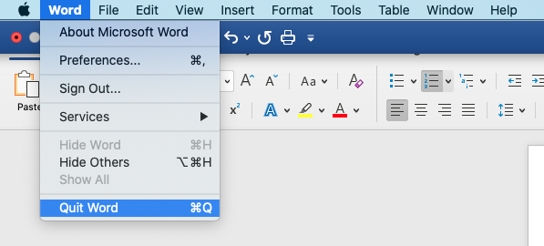

Option 2:
You can go to the App icon down the bottom of your screen in the Dock, right click on it and then click on Quit. 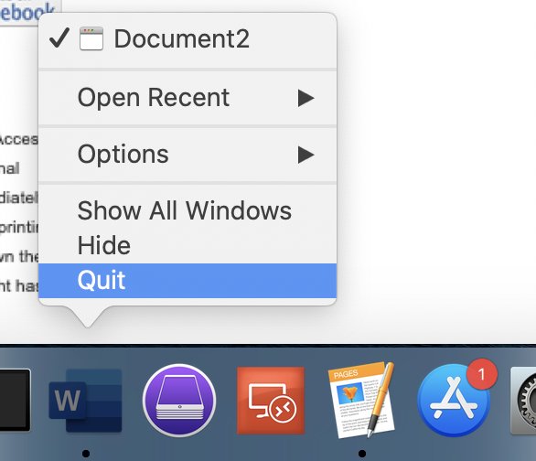

Option 3:
You can press the following keys on your keyboard: Command + Q

Use Force Quit if the normal Quit option isn’t working for you.
- Go to the Apple Logo in the top Left Menu bar, then click on Force Quit.
- A box will appear showing all the Apps currently running.
- From the list, select the app you want to close down, then click on ‘Force Quit’
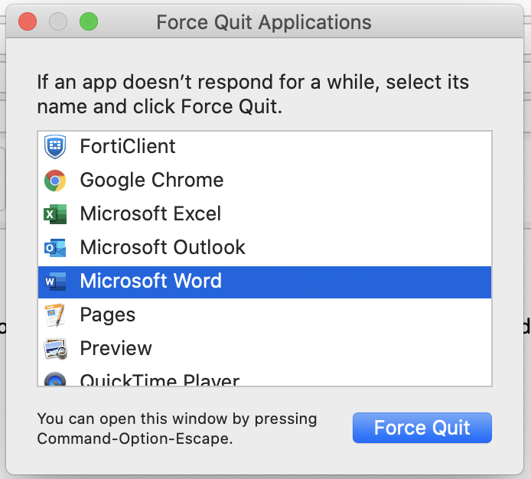

Restart your MacBook.
- If all else fails, restart your MacBook and see if this fixes your issues. To restart use one of these methods.

Option 1:
Go to the Apple Logo in the top Left Menu bar, then click on ‘Restart’

Option 2:
If your Mac is frozen and you are unable to click on the Apple logo or it simply won’t restart your Mac, then Press and hold the power button on your mac for about 10 seconds.
    - Wait about another 5 seconds and then power your Mac back on as per normal

Make sure you Save your Work to a specific Location
- If you open a file directly from an email, YOU NEED TO SAVE IT to your own specific location before making changes to it.
- Open the file and then go to File>Save As
- Then Select your specific folder such as Desktop or Documents or one that you have specifically created for your particular subject.
- Choose to Save it.
- Now you know exactly where this file is located, and this is what you will work on from now on … NOT the original file from the email.

And Save your work OFTEN
- Press the save button regularly as you work so that you minimize any chances of losing your data.

