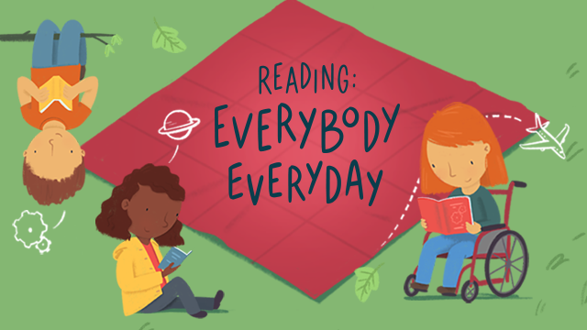

Books Links Term 2 Week 5

Just Like My Dad // Read-Along https://www.youtube.com/watch?v=Udw9FpQpOe8

Splish, Splash, Ducky! by Lucy Cousins | Read aloud https://www.youtube.com/watch?v=g88WCWyGBoc

From Head to Toe by Eric Carle || ANIMAL SOUNDS! https://www.youtube.com/watch?v=Vjum-5bNmz0

Baby Bear, Baby Bear, What Do You See? https://www.youtube.com/watch?v=DPTb10tLEqk

The Dinosaur Who Lost His Roar - Give Us A Story! https://www.youtube.com/watch?v=ppyiuCyNGqY

My Grandparents Love Me by Claire Freedman, read aloud https://www.youtube.com/watch?v=O6PMBp4nzAA

Mo's Smelly Jumper by David Bedford https://www.youtube.com/watch?v=23yyMlULlNE

When Your Lion Needs A Bath | Read Aloud https://www.youtube.com/watch?v=d9C47HYBkK8

Boa's Bad Birthday by Jeanne Willis & Tony Ross - Read Aloud Story https://www.youtube.com/watch?v=3Cfro4l_DqU

The Selfish Crocodile https://www.youtube.com/watch?v=tB60DlZh4GI

Piranhas Don't Eat Bananas https://www.youtube.com/watch?v=v_gmtF0f3Cs

The Pout Pout Fish and the Bully-Bully Shark - By Deborah Diesen https://www.youtube.com/watch?v=Dq-lR8XgCc0

The Pout Pout Fish Goes to School Read Along https://www.youtube.com/watch?v=IJq8WnsHRqY

There's a Lion in my Cornflakes - Give Us A Story! https://www.youtube.com/watch?v=yIlTq_SvlDg

The Very Lonely Firefly by Eric Carle | A glowing tale! https://www.youtube.com/watch?v=_XrPyF4Mpl4

A House for Hermit Crab by Eric Carle || Undersea Adventure! https://www.youtube.com/watch?v=0UlGQUNLwAQ

Usborne Farmyard Tales | New Pony | The Grumpy Goat | Children's Book Reading https://www.youtube.com/watch?v=4_NrGClzNjE

Pete the Cat and The Treasure Map | Read Aloud https://www.youtube.com/watch?v=c4U9bz_Vj4U

Pete the Cat and The Bad Banana | Read Aloud https://www.youtube.com/watch?v=ivNWgwiEWKc&t=61s

Clark the Shark: Tooth Trouble https://www.youtube.com/watch?v=u7gZhQQxxEo

Biscuit Read Aloud https://www.youtube.com/watch?v=sepONRwZUCM&t=1s

Biscuit and the Lost Teddy Bear Read Aloud https://www.youtube.com/watch?v=uoChO6nLNnU

Pink around the Rink (Pinkalicious) https://www.youtube.com/watch?v=uTuktsQbfHI

Pinkalicious Pinkie Promise -READ ALOUD https://www.youtube.com/watch?v=RAjovc060kg

If You Give a Pig a Pancake Read Along https://www.youtube.com/watch?v=jNiAktHBZa4

Franklin in the Dark Read Along https://www.youtube.com/watch?v=wdXYyNSfKGs

Hey, Little Ant https://www.youtube.com/watch?v=ehH6l6v5sYM

Dragons Love Tacos https://www.youtube.com/watch?v=Btlna6Dvv3c

A Fox Found A box - Read Aloud Book Family https://www.youtube.com/watch?v=ONVdmvenMz8

The Best Teacher in Second Grade Read Along https://www.youtube.com/watch?v=LShjcIaVUEM

HARRY THE DIRTY DOG ~ Read Along Story Time https://www.youtube.com/watch?v=YjqGcchpN9o

Crazy Hair Day https://www.youtube.com/watch?v=8hBo7LwEafg

Have You Thanked An Inventor Today? | Storytime Books Read Aloud https://www.youtube.com/watch?v=Dcwvzg07PUY

Cece Loves Science and Adventure https://www.youtube.com/watch?v=B3kEDJMTxwM&t=5s

Cece Loves Science Book Read Aloud For Children https://www.youtube.com/watch?v=ysnf0gZuVWo&t=13s

Hair Love | Storytime Books Read Aloud https://www.youtube.com/watch?v=veac8ZkmXB8

There Was An Old Lady Who Swallowed Some Books! Read Aloud https://www.youtube.com/watch?v=HARhjB0K0Uo

Salt in His Shoes https://www.youtube.com/watch?v=1BFa2ELyMfo

The Relatives Came https://www.youtube.com/watch?v=AOPfS50xve4

The Three Billy Goats Fluff https://www.youtube.com/watch?v=lkt8XrGgjPk

The Paper Bag Princess https://www.youtube.com/watch?v=OCO21zo7m2c

SHARKS | Animal Book for Kids Read Aloud https://www.youtube.com/watch?v=e16aXiLWONk

SNAKES | Animal Book for Kids Read Aloud https://www.youtube.com/watch?v=xTYZ-Hhev2g

Let"s Read: Amazing Snakes. https://www.youtube.com/watch?v=fJInJzXQveM

Fly Guy Presents : Snakes - Read Aloud https://www.youtube.com/watch?v=03r5wwIBIH0

Fly Guy Presents Weather https://www.youtube.com/watch?v=ebMtKJahKNg

Super Storms https://www.youtube.com/watch?v=48xKkpM3gYQ

Wolves By: Laura Marsh https://www.youtube.com/watch?v=9QGvXb6L0pM

