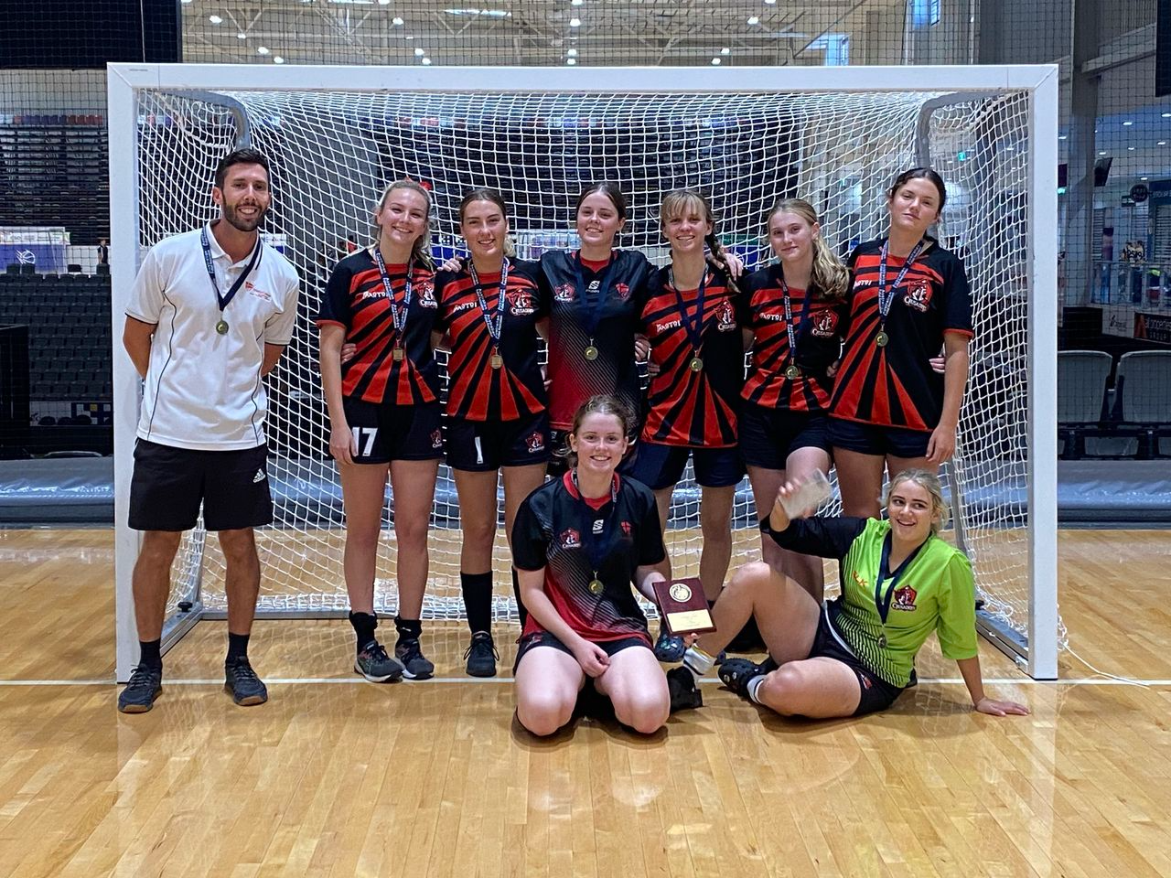

Trinity College HPE & Sports Handbook 2024

Table of Contents
TRINITY’S VISION FOR HPE AND SPORT 4
HEALTH, PHYSICAL EDUCATION AND SPORT CURRICULUM 5
TRINITY COLLEGE 2024 SPORT OVERVIEW 7
HPE AND SPORTS STAFF 8
PATHWAYS 9
CARNIVALS 10
DISTRICT AND REGIONAL REPRESENTATION 12
TRINITY COLLEGE CRUSADERS 14
CHRISTIAN SCHOOLS LEAGUE 15
CHRISTIAN SCHOOL SPORT ASSOCIATION OF QUEENSLAND 17
SPORTS AEROBICS 19
HIGH PERFORMANCE UNIT 20
WEDNESDAY & FRIDAY AFTERNOON ACTIVTIES 21
FAMILY OPPORTUNITIES 23
RECOGNITION OF SPORTING ACHIEVEMENTS 23
2024 INFORMATION NIGHT 26
SPORTING APPAREL 27
TESTIMONIALS 29
Sports Calendar 2024 31
Sporting pathways – 2024 33

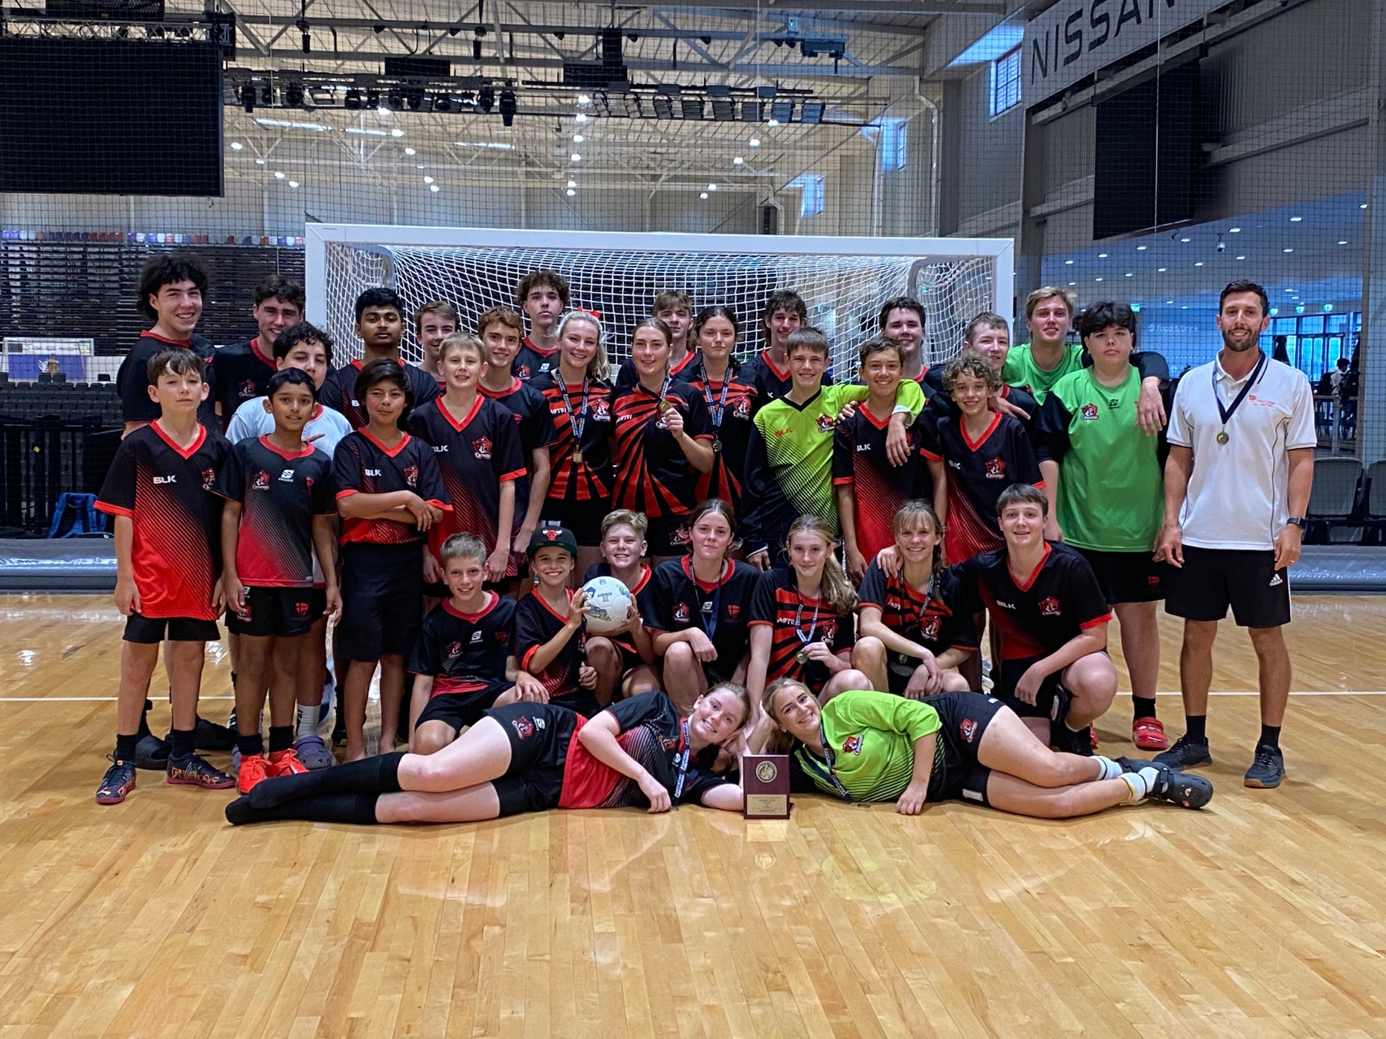

TRINITY’S VISION FOR HPE AND SPORT

Developing life-long social, spiritual, and physical skills

This is our core business so everything we invest into is based on developing students holistically. Therefore, we hold carnivals, train teams, run camps, play in interschool competitions and have travelling sports teams. Everything we do is wrapped up in this one simple statement.

HEALTH, PHYSICAL EDUCATION AND SPORT CURRICULUM

The HPE faculty is an integral part of the school curriculum, in an increasingly complex, sedentary, and rapidly changing world it is critical for every young Australian to not only be able to cope with life’s challenges but also to flourish as healthy, safe and active citizens in the 21st century.
Students at Trinity have the chance to engage with Health and Physical Education in the following ways:
- P-10 Core HPE
- Physical Literacy Program P-6
- Wednesday afternoon activities Grades 4-6
- Friday afternoon activities grades 7-12
- Year 9/10 Sport and Recreation Elective
- Year 9/10 Outdoor Education Elective
- Senior PE
- Senior Health
- Senior Sport and Recreation
- Certificate 2 in Sport and Recreation Certificate 3 in fitness – delivered on-site.
Our staff are proud to use evidence-based teaching strategies and pedagogies to engage all students. This includes:
- Inquiry-based learning
- Play with Purpose/Game Sense into Sport Literacy (Pill, 2014).
- Sports Education Model
- High Impact teaching strategies (DET, 2019).
Students have lots of opportunities as part of our curriculum to enhance leadership capacity and embed their learning and assessment in authentic ways through sporting opportunities including carnivals and events. Examples include:

- Training for upcoming school sporting carnivals that focus on student self-improvement and competition.
- Coaching and umpiring at the Christian school’s league gala day.
- Running one of the school sporting carnivals.
- Promoting cultural sports activities.
- Sports captain opportunities.

An overview to develop our student’s physical literacy can be seen below:

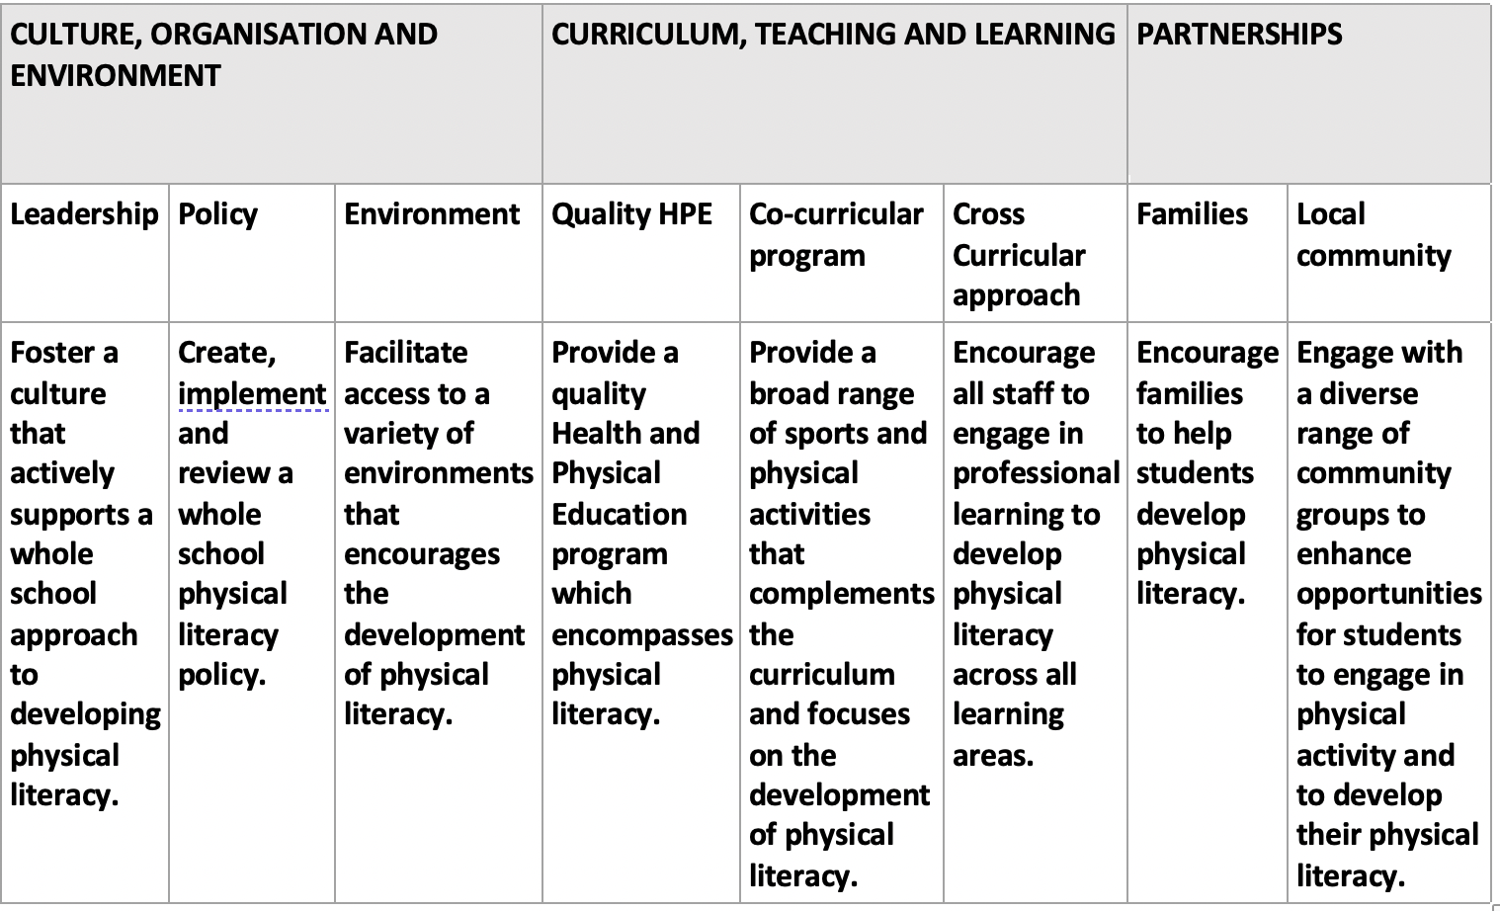

TRINITY COLLEGE 2024 SPORT OVERVIEW

 | Term 1 | Term 2 | Term 3 | Term 4
School Carnivals | 7-12 Swimming  P-12 Cross Country | 7-12 Athletics  P-6 Athletics | P-3 Sports Day | P-6 Swimming Celebration
Christian Schools League |  | Round 1 - Gladstone  Basketball  Netball  Softball  9a side soccer | Round 2 – Rockhampton  Futsal  Touch Football  Volleyball  Ultimate Frisbee
District interschool sports | Basketball (GBA) | Basketball (GBA)  Netball (PC)  Netball (GNA) | Touch Football (PC)  Basketball (GBA)  Netball (GNA) | Football  Basketball (GBA)
Clubs | KM club (Grade 4-6 and 7-12)  Sports Aerobics – Monday mornings  HPU  Volleyball  Basketball  Netball  Junior Soccer Clinic | KM club (Grades P-3)  Sports Aerobics –Monday mornings  HPU  Volleyball  Basketball  Netball | Sports Aerobics – Monday mornings  HPU  Volleyball  Basketball  Netball | Sports Aerobics – Monday mornings  HPU  Volleyball  Basketball  Netball
Crusader sports | Swimming  Futsal | Basketball  Futsal  Cross Country  Volleyball | Futsal  Netball  Athletics  Volleyball | Basketball  Futsal

HPE AND SPORTS STAFF

- Wynand van Zyl, Director of HPE and Sport - Organisational leadership, oversight, and management of HPE and sport faculty
Wynandv@trinitygladstone.qld.edu.au

- Brooke Wildey, Sports Co-ordinator – Co-ordinate and promote K-12 sporting events including WAA and FAA.
brookew@trinitygladstone.qld.edu.au

- Janine Hobbs, Sports Administrator – Administrative and clerical support for the team including nominations for district sports and coaching where possible.
sportsadmin@trinitygladstone.qldedu.au

- Kirstin Muir HPE teacher

- Danae Fitzgerald, HPE teacher

- Wynand van Zyl, HPE teacher

All sports information will be advertised throughout the year in the following ways:
- For major events such as the swimming, cross country, athletics, and CSL carnivals an email with a letter is sent home to all families.
- Annual Sports information evening in term 1.
- School newsletter.
- College Sports Handbook on the school website.
- Trinity College Gladstone Sport Facebook group - https://www.facebook.com/groups/188983313081137
- Sports notice board outside the Sports office.
- School chapel.

PATHWAYS
Trinity College offers pathways in sport from HPE classes through to national level competitions all while being part of the living, learning, and community of Trinity College. Aligned with the Australian Institute of Sport FTEM framework, these pathways are as follows and can be seen in greater detail at the end of the handbook:
https://www.ais.gov.au/ftem
Steps |  | Example
Step 1 Participation | Students learn skills and understanding and tactical skills as part of the National curriculum. Students participate in a competitive environment through school opportunities. | - HPE classes  - Wednesday Afternoon activities  - Friday afternoon activities
Step 2 Play | At this stage, students try out and are selected into teams to participate against other schools in a more competitive environment. Students train during the week. | - Interschool Sports  - Christian Schools league
Step 3 Perform | Students who are performing at a very high level and are selected to represent the school at the highest level. | Traveling Crusader teams:  - State titles
Step 4 Professional Partnerships | Students at this level are aligned with stakeholders and sporting pathways to help them use their God given talents as a pathway for further education, university, and professional sport. | -Football Queensland  - AFA

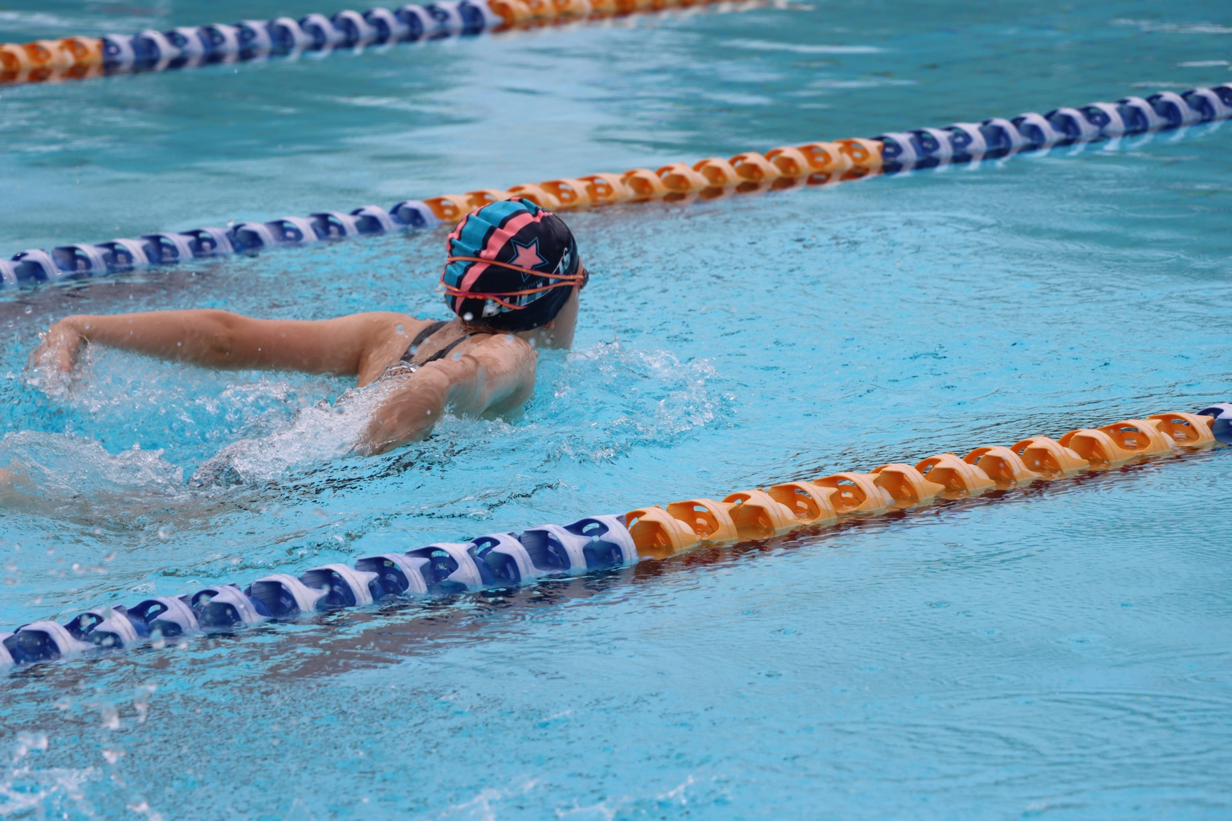

CARNIVALS

Swimming Carnivals
Trinity hosts two Swimming Carnivals each year, the year 7-12 carnival and the P-6 swimming celebration.
The year 7-12 Swimming Carnival is the first carnival of the year and is a fantastic opportunity for students to participate in a variety of competitive and novelty swimming events. During all our sporting carnivals friendly house rivalry is encouraged as students compete for the prestigious swimming house champion trophy and other individual awards. The results collated from this carnival are used to determine the Trinity College swimming squad who compete at a Christian Schools Sporting Association (CSSAQ) swimming carnival in Brisbane.

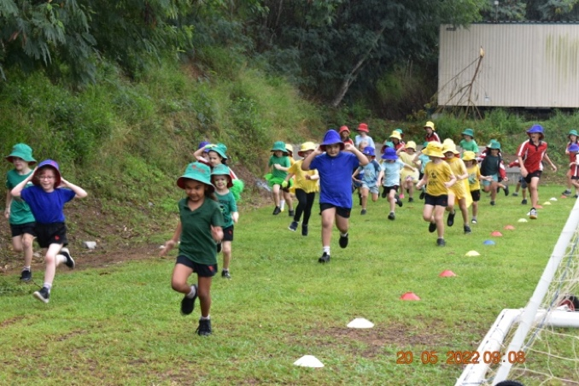

The P-6 swimming celebration is the culminating event of term 4 to celebrate the P-6 students’ success in their HPE swimming classes.
Cross Country Carnivals
There is one Cross Country Carnival each calendar year, the year P-12 carnival brings the entire community together for half a day of fun in the sun. Apart from all the festivities, the carnival is about cross-country running, and all participants are cheered on by parents and peers. The results for students aged 10-18 Cross Country Carnival are used to select the top students to make the Trinity College cross country squad who compete at the district level. Students who meet qualifying from the district trials are also eligible to go on and be selected for regional and state teams. Students can then have an opportunity to compete at the Christian Schools Sporting Association (CSSAQ) in Brisbane.
Athletics Carnivals
There are two Athletics Carnivals each calendar year, the year 7-12 carnival and the P-6 carnival. Both competitive and non-competitive athletes can participate in various athletic disciplines. The results from the Athletics Carnivals for students aged 10-18 are used to form
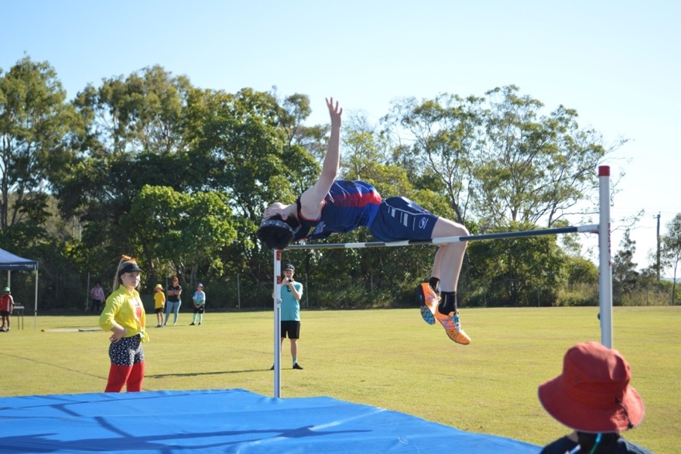

the Trinity College athletics team that competes at the district carnival and then can go on and be selected for regional and state teams.

DISTRICT AND REGIONAL REPRESENTATION
Pathway and Trial information for Queensland school sports.
For a number of sports there is a Queensland school sport pathway to represent the district, region and state. Trials are held throughout the year. Information can be found here: https://capsport.eq.edu.au
- All sports information for trials will be advertised throughout the year in the student notices and through the school sport Facebook here: https://www.facebook.com/groups/188983313081137
- Specific trial paperwork will then be posted in the school Google Sports Drive which families can access at any time here: https://drive.google.com/drive/folders/18C2UmJyufZOlXq7ryJqiG5TuuNAQt_Ze?usp=sharing

Sports Offered
10-12 Year old’s | 13-19 Year old’s
- AFL  - Aquathlon  - Athletics  - Basketball  - Boys Cricket  - Boys Rugby League  - Cross Country  - Football (Soccer)  - Girls Cricket  - Girls Rugby League  - Golf  - Hockey  - Netball  - Rugby Union  - Softball  - Squash 10-19yrs  - Swimming  - Tennis  - Touch Football  - Volleyball 12-15yrs | - AFL 13-14 boys  - AFL 13-14 girls  - Basketball 13-15 years  - Basketball 16-18 years  - Boy’s rugby league 14-15 years  - Boy’s rugby league 16-18 years  - Cricket 13-14 boys  - Cricket 13-15 girls  - Cricket Boy’s 16-19  - Cross Country 13-19 years  - Girl’s rugby league 14-15 years  - Girl’s rugby league 16-18 years  - Golf  - Hockey 13-19 years  - Netball 13-15 years  - Netball 16-19 years  - Rugby Union 14-15 years  - Rugby Union 17-18 boys  - Rugby union 7s girls 15-16 years  - Football 13-16 and 13-15 Girls  - Football 17-19 and 16-19  - Softball 13-19 years  - Squash 10-19 years  - Surfing 13-19 years  - Swimming 13-19 years  - Tennis 13-19 years  - Touch Football 13-15 years  - Touch Football 16-18 years  - Track and Field 13-19  - Triathlon 13-19 Years  - Volleyball 12-15 years  - Volleyball 16-19 years  - Waterpolo

TRINITY COLLEGE CRUSADERS
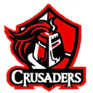

The Trinity College Crusaders are the schools travelling sporting teams. Sporting opportunities extend beyond the sporting life available in Gladstone and offer developmental pathways from local to state level competition while playing under the Trinity Crusaders banner. Sports offered include:

- Basketball
- Futsal and Football
- Netball
- Volleyball
- Swimming
- Athletics
- Cross Country
- More sports to come …

Some achievements to date for the Crusaders team include:

- Futsal QLD state champions 2023
- Capricornia Futsal champions 2023
- Bundaberg regional champions futsal 2023
- Primary Interschool Gladstone Football 2023
- Mountain Bike national titles 2019
- State Netball CSSAQ grade 7/8 champions 2022
- Basketball CSSAQ state attendance 2023
- 2017 All school Rugby 7s runner up
- Bundaberg 7s Girl’s winners 2021
- Christian Schools League Champions 2023 – 5th year overall winning school
- Percentage point school champions at the CSSAQ Swimming state carnival 2023

CHRISTIAN SCHOOLS LEAGUE
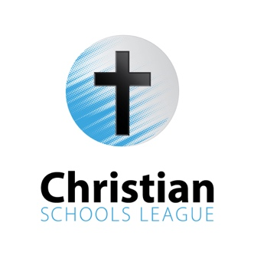
History
In 2023 Trinity College participated in two rounds of the Christian Schools League. The Christian Schools League is a sporting competition created by Trinity College in 2019 aimed to give opportunities for primary and secondary students to participate in a quality sports program and grow community and partnership between Christian schools in Central Queensland. The competition offers opportunities to Boys, Girls and mixed sports across both Primary (4-6) Middle (7-9) and Senior (10-12) Divisions. In 2023 the competition involved 7 Christian schools, 8 sports, over 112 teams, and over 800 students across two rounds. The CSL also gives students an authentic opportunity to apply their HPE studies into the community in an authentic way using the Sports Education model. Students are given the opportunity to develop leadership skills through the experience of taking on roles such as:
- Sports board
- Record keeping
- Umpiring
- Coaching

Vision and Mission
- Quality sport and Christian Community
- Give opportunities for primary and secondary students to participate in high quality sport that don't have the opportunity to already.
- Grow community and partnership between Christian schools in Central Queensland.

Competitions and Sports offered in 2024

Round 1 – Term 2 Gladstone 2024 | Round 2 – Term 3 Rockhampton 2024
Basketball | Futsal
Netball | Touch Football
Backyard Cricket | Volleyball
6a side Soccer | TBC

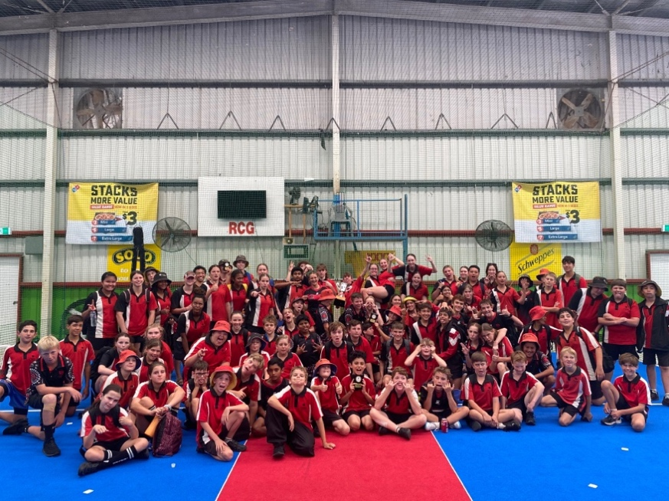

CHRISTIAN SCHOOL SPORT ASSOCIATION OF QUEENSLAND
The Christian School Sport Association of Queensland state titles exists to promote sportsmanship and healthy competition for students in years 4 to 12. CSSAQ member schools consist of Australian Christian Schools (ACS) and Christian Schools Australia (CSA) networks. CSSAQ provides opportunities for athletes in both team and individual sports. ​
Opportunities include: ​
- Athletics
- Cross Country
- Swimming

- Team Sports
- National Games
In 2023 Trinity College attended the:
- State CSSAQ swimming carnival
- State CSSAQ basketball carnival
- State CSSAQ netball carnival

SPORTS AEROBICS

Sports aerobics originates from traditional aerobics whilst also combining fitness & dance with the ability to perform skill elements and movement patterns with music, at a high intensity. In 2023 we were blessed to have our very own teams perform at the FISAF Australian Super Series in Gladstone representing the school.
- Students from years 3-12 welcome
- Training every Monday from 8- 8.30 am in the music room
- Cost – approx. $40 per child for leotard and tights (only if they plan on participating in the competition). Gladstone Super Series Competition – Saturday 3rd June

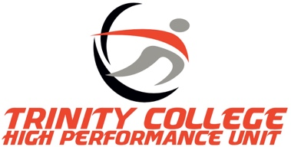
HIGH PERFORMANCE UNIT

The Trinity College High Performance Unit (HPU) is designed to help our athletes improve sport-specific strength, conditioning, and skills over the long term. The program is run through the state-of-the-art HPU gym, all students at the Capricornia or club representative level can apply to take part in the HPU. Regardless of what sport students play, the focus of the HPU is on improving athletic ability.
The HPU is partnered with Gladstone Physio and Fitness and has two Exercise Physiologists who work in the program to help students achieve their goals. The team are committed to ensuring the development, understanding and maximum benefits achieved from the HPU are consistent over time.
There are currently two groups that train before school two days per week, the Monday and Wednesday group, and the Tuesday and Thursday group. All students are put through goal setting and fitness testing to ensure that all programs are periodised to their sports, competitions, and individual needs. Students also learn about the importance of rest, recovery and nutrition to support them in their sporting and academic pursuits.
If students wish to apply, they can contact Brooke Wildey brookew@trinitygladstone.qld.edu.au
Some athletic achievements to date for students who are involved in the HPU include:
- State level Softballer
- State and National level Rugby union players
- State and National winning Touch players
- State level Tennis players
- State level Track and Field athletes
- State level Swimmers
- State and national level Futsal and Football students
- State level Volleyball player
- Representative Basketball players
- State level Cricketers
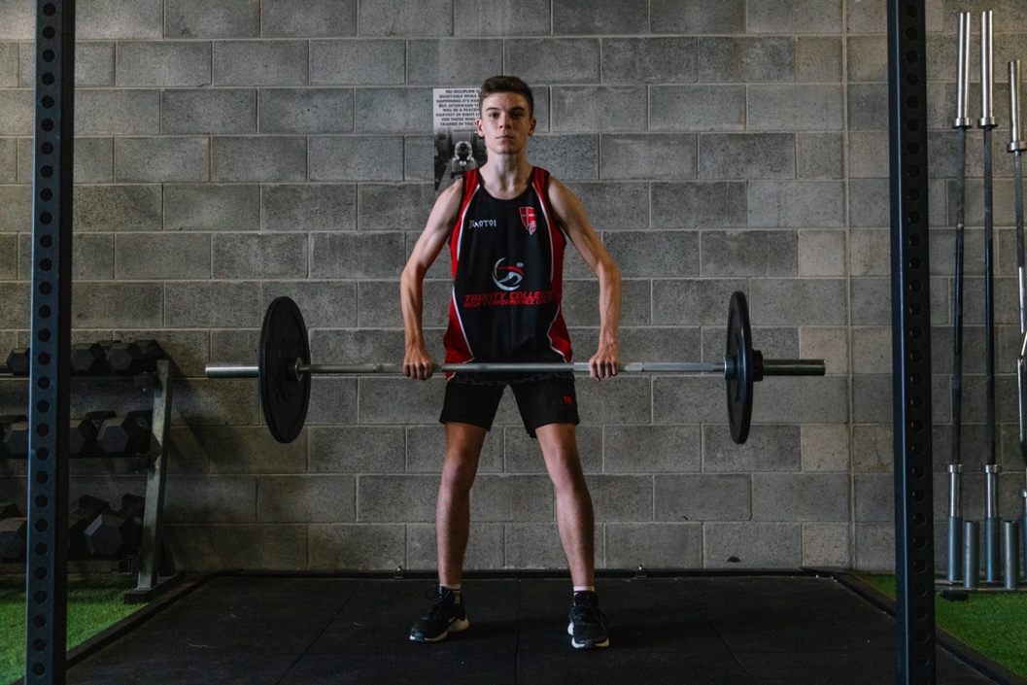

WEDNESDAY & FRIDAY AFTERNOON ACTIVTIES

Sport, recreation, and passion-based activities are a vital part of the Trinity College Gladstone co-curricular program. Fortnightly, for primary school (grades 4-6), and weekly for high school (7-12), students are timetabled to participate in Wednesday and Friday afternoon activities which provides them with the opportunity to develop their God-given talents and abilities within a healthy, dynamic and supportive environment.
Students select the activity they would like to be a part of. The College aims to give every student the opportunity to benefit from this learning through a variety of sports, recreation, and passion-based activities during the year. The sporting activities give students opportunities to train for their chosen sporting teams during the school day and lead to competitive pathways representing the school at district, regional, state and national level. Research shows that students who have greater autonomy in physical activity preferences are more likely to stay active for life. Activities vary throughout the year and some of them include:

Sport | Recreation | Passion
Basketball  Cross Country  Futsal/Football  Netball  Rowing  Rugby 7s  Swimming  Touch Football  Track and Field  Volleyball  Interhouse sports | Beach Games  Outdoor activity club – bushwalking, mountain biking, surfing, canoeing etc  Chess  Cross Fit  Dancing  Golf  Gymnastics  Hub fitness/Gym  Pilates  Skateboarding/Scootering  Tennis  Ultimate Frisbee | Cooking  Design (STEM)  Fishing  Photography  School Musical  Study

FAMILY OPPORTUNITIES
Part of Trinity’s mission is live, learn and have community. We believe families are a big part of this, so we want them to be involved.
Below are some ways you can be involved.
Contact Brooke Wildey brookew@trinitygladstone.qld.edu.au
- Carnival help (timing, officiating) and training
- Coaching, managing, or volunteering at the CSL
- Managing a Crusaders team
- Assisting at running club or athletics training
- Coaching or managing a Friday afternoon activity.
* If you are passionate about a particular area of sport and it isn’t listed please contact the school.

RECOGNITION OF SPORTING ACHIEVEMENTS
Facebook page and Trinity Tribune
We recognise several students and teams in both the Trinity Tribune and the school Facebook page. Follow us at https://www.facebook.com/groups/188983313081137
Yearbook
At the end of the year Trinity College produces a yearbook which includes photos and articles of all the year’s curricular and extra-curricular activities. As part of this yearbook Trinity’s sporting teams, district sport finalists/champion teams and representative athletes are recognised .
P-6 Carnivals – Swimming, Cross Country, Athletics
P-6 carnivals emphasise qualities such as sportsmanship, teamwork, and life skills rather than direct competition between students. This gives all students the chance to succeed and therefore foster a love of being active and will build towards a more competitive nature by Grade 4. Research clearly indicates that competition too early can turn students away from physical activity in their teens leading to a health crisis as we are seeing currently in
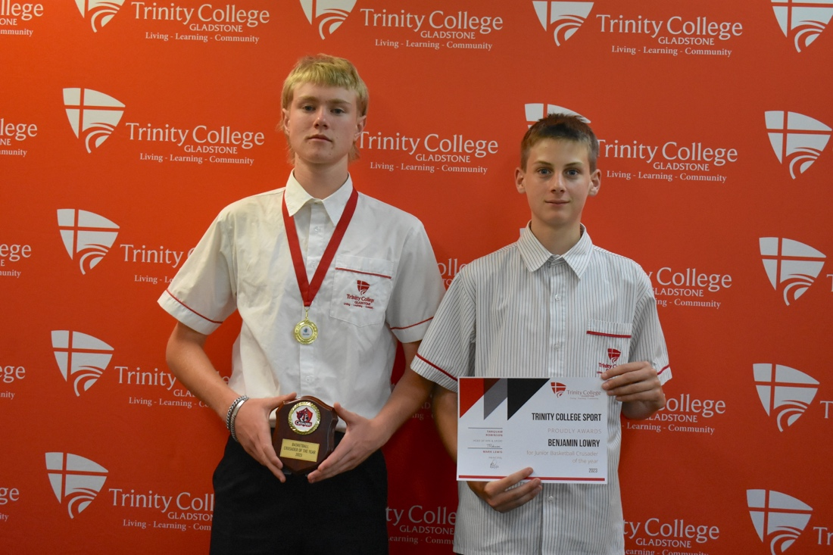

adolescents with only 1 in 10 getting the required physical activity levels each day (AIHW, 2018). Awards include the following:
- Sporting star class award – recognising student's fundamental movement skills developed in HPE classes
- Fruit of the Spirit class award – recognising student Christian qualities
- Philippians 4:13 class award - recognising student effort
- Ecclesiastes 4:9-10 class award – recognising students' teamwork
Secondary year 7-12 Carnivals – Swimming, Cross Country, Athletics
The athletes are recognised with the following at the conclusion of the carnivals:
- Age Champion medallions
- Most improved Cross-Country medallion boy and girl
- Most improved swimming medallion boy and girl
- Overall track champion boy and girl
- Overall field champion boy and girl
- First, second, third place ribbons for all events

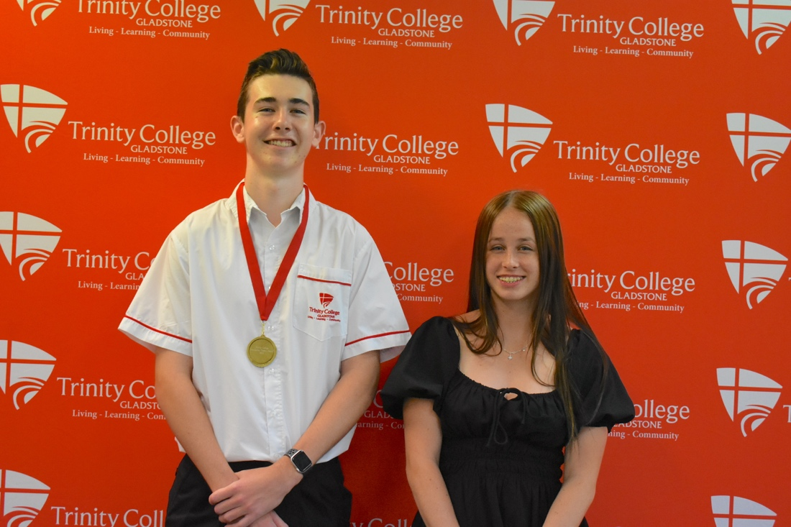

Sports Awards Night
The highlight of the sport calendar is the annual sports awards night. This is held in Term Four with special guests and several awards to recognize student excellence in sport throughout the calendar year. The event is to celebrate individual and team student success as a community.
The following are awarded at the sports award’s night:
- Port Curtis interschool team of the year
- Queensland school sport representative recognition
- Year 4-12 swimming carnival records
- P-12 cross country carnival records
- P-12 athletics carnival records
- Everlasting Crowns Award
- Recognition of sporting excellence outside of school – state and national level
- Christian schools league team of the year
- Trinity crusader player of the year
- Trinity crusader team of the year
- Overall sporting house
- Trinity sports service award
- 4-6 Trinity Sportsman and sportswoman of the year
- 7-12 Trinity Sportsman and sportswoman of the year

2024 INFORMATION NIGHT
Early in term 1 2024, the HPE and Sport department will be hosting a ‘Sports Information Night’ to discuss the school’s vision, plans and opportunities in 2024 and beyond. The evening will also include a light snack, tea and coffee to allow parents and students the opportunity to meet sporting coaches, teachers and ask questions that they may have. An outline of the evening includes:
- Sporting pathways
- School Carnivals
- Representative sport
- Crusader sports including:
  - Netball
  - Basketball
  - Futsal/Football
- Christian Schools League
- High Performance Unit
- WAA/FAA
- Parent opportunities
- Recognition of sporting achievement

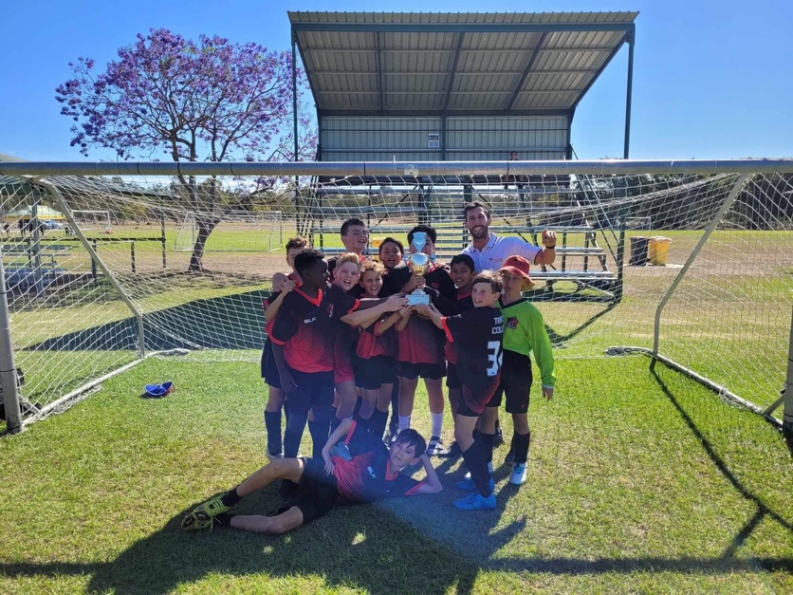

SPORTING APPAREL

In 2021 a member of the student council and a number of students approached the HPE and Sports department about sporting apparel. Students voiced their desire to have branded merchandise that could be worn at sporting events when representing the college. As an HPE and Sports team, we conducted some evidenced-based research into this proposal from students and cross-referenced our values and goals as a department to determine if this is something we wanted to support and reflected the college’s ethos. Our goal as an HPE and Sports team is to ‘Develop life-long, social, physical and spiritual skills’. This is our core business so everything we invest into is based on developing students holistically. Therefore, we hold carnivals, train teams, run camps, play in interschool competitions and have travelling sports teams. Everything we do is wrapped up in this one simple statement.

AusSport completed a paper on ‘Addressing the decline in sport participation in secondary schools’, the findings from the Youth Participation Research Project (2017) found that student excitement and engagement increase when programs have merchandise or branded uniforms.
Based on our research and passion to continue growing our Trinity Crusaders sports program so that students are able to best use their God-given gifts and talents, Trinity College has the chance to partner with Struddys sports https://struddys.com.au. All students who are involved in the school sporting programs can buy their apparel from this website and be able to get the correct size and customize it to their own preference. This can include students’ names, numbers and the sporting team or code they belong to. For example, you may choose to have your name ‘Robinson’ and ‘Basketball’ written on your hoodie. Students’ names are only permitted to be their own first or last name, no nicknames are acceptable. This is to avoid any concerns regarding name selection or inappropriate choices in alignment with the college’s ethos and beliefs. Failure to adhere to this will mean students are unable to wear their sporting apparel during their permitted times.
Once items have been ordered using the online link they will be shipped to the college for collection. We have limited the items for 2024.

When can these items be worn?

Students are not permitted to wear sporting apparel instead of standardised school sports uniforms. If students wear this uniform in an incorrect manner, there will be consequences deemed appropriate by the college in alignment with the school uniform policy agreed upon at enrolment into the college.

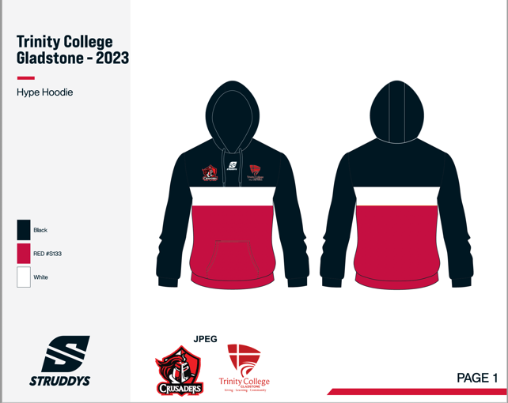
To ensure all families and students understand the rules regarding this matter students will only be able to wear their apparel at the following times:

Sporting events, training or matches such as:
- High-performance unit training sessions
- Training sessions outside of school hours
- Sports Carnival days such as swimming, cross country, and athletics carnivals.
- Sporting camps or trips such as the CSSAQ netball, basketball, or state futsal trip.
- CSL gala days

TESTIMONIALS

- Friday Afternoon Activities has incorporated a variety of different sporting options for students to choose from. The addition of mountain biking this year has been popular with my son – Parent

- A highlight has been during sporting carnivals HPE staff focus on student self-improvement as much as they do age champions. My daughter loved beating her PB at the cross country carnival, even though she didn’t place, she was incredibly proud of her effort and this really improved her own self-confidence. - Parent

- As students, we really valued the time and attention given to various sports and HPE offerings. The variety is very great, and this means that it appeals to many students and draws people into the college – Former student

- The programs at the school have impacted students, staff and the community. As a staff we have been blown away on the emphasis not just on student outcomes but also student wellbeing – Trinity Staff member

- The programs offered by the school adds a sense of culture and community. Many students bond together because of they play in teams together. I've also been able to build relationships and respect with students because of school sporting trips and events – Trinity Staff member

- The CSL has been a really positive experience for my kids, and it gives them a goal to aim for at the end of term - Parent

- Sporting and HPE curriculum opportunities are a massive drawcard for my kids attending the school - Parent

- The HPU (High-Performance Unit) has been such a game-changer for my daughter and will be forever grateful for the HPE teams hard work – Parent

- I love that sporting carnivals include the students in a variety of ways including running the day, umpiring and coaching - Former student

Sports Calendar 2024

TeRm one
Tue 30/01/24 | Sports Info evening  4pm – 5pm
Fri 16/02/24 | 7-12 Swimming Carnival
Fri 22/03/24 | P-12 Cross Country
Mon 11/03/24  (10-12 March) | CSSAQ Swimming  (leave the 10th and return the 12th)
Wed Weekly Wk 5 onwards | Soccer Clinic (Prep – Year 3)

TErm two
Tue 30/04/24 - Thu 2/05/24 | Bundaberg Futsal  (Day trips)
Fri 3/05/24  (8th-9th of May) | CSSAQ Netball  (Leave the 8th and return the 9th of May)
Wed 8/05/24 | Port Curtis Cross Country
Thu 30 May and Fri 31 May | Rockhampton Futsal  (Day trips)
23/05/24 | P-6 Athletics Carnival
24/05/24 | 7-12 Athletics Carnival
Fri 31/05/24 –Sun 2/06/24  (30th of May – 3rd of June) | Qld Volleyball Intermediate Schools Cup  (Leave the 30th of May and return the 3rd of June)
Fri 14/06/24 | Zones Athletics
TBC | CSL Round 1

TErm Three
Fri 19/07/24 | P-3 Sports Day
Tue 23/07/24 – Wed 24/07/24 | Port Curtis Athletics
Thu 9/08/24 – Sun 11/08/24  (8 – 12 Aug) | Qld Volleyball Senior Schools Cup  (Leave the 8th of Aug and return the 12th of Aug)
Mon 12/08/24 –Tue 13/08/24 | CSSAQ Athletics
Thu 15/08/24 - Fri 16 /08/24 | CSSAQ Football (yr 7-10)  CSSAQ Football (Boys year 11/12 and Girls year 7-9)  (Leave the 14th of August and return the 17th of August)
Tue 20/08/24 | CSSAQ Basketball – Year 7-12  (Leave the 19th of August and return the 21st of August)
Fri 06/09/24 | CSL Round 2

Term four
Wed 9/10/24 | State Futsal Titles
Fri 22/11/24 | Prep to Year 6 Swimming Carnival
Fri 29/11/24 | Adventure Trip

Sporting pathways – 2024

 | Basketball | Futsal | Netball | Athletics | Cross Country | Swimming | Volleyball
Professional Pathways  Students at this level are aligned with stakeholders and sporting pathways to help them use their God given talents as a pathway for further education, university, and professional sport. | Port City Power  Queensland School Sport | Football Queensland  Australian Futsal Association | Netball Queensland  Queensland School Sport | Queensland Athletics  Queensland School Sport | Queensland Athletics  Queensland School Sport | Swimming Queensland  Queensland School Sport | Volleyball Queensland  Queensland School Sport
Perform  Top performing students in teams are selected to make up the strongest Trinity teams. Top individual students are selected in their qualified events. | CSSAQ  Capricornia | State titles | CSSAQ  Capricornia | State Carnival  Capricornia Carnival | State Carnival  Capricornia Carnival | CSSAQ  State Carnival  Capricornia Carnival | State Schools Cup
Play  Students trial to be selected into teams or qualify through individual events to get to the next level of competition. | GBA  CSL  Port Curtis | PC Interschool  CSL  Bundaberg, Harvey Bay and Rockhampton school titles | PC interschool  CSL  Port Curtis | PC carnival  School Carnival | PC carnival  School Carnival | PC carnival  School Carnival | GVA  CSL
Participate  Student’s study this as part of the HPE syllabus or can elect to participate during WAA or FAA. | HPE  WAA  FAA | HPE  WAA  FAA  Primary Clinics | HPE  WAA  FAA  Primary Clinics | HPE  Athletics club  WAA  FAA | HPE  KM club  FAA  WAA | HPE  FAA  WAA | HPE  WAA  FAA

